EL213: Computer Org. & Assembly Language

# Lab#01: Assembler’s Installation

## Agenda

* Introductions to Assemblers & Editors
* Assembly Programming
* Installation of MASM
* Assembling, Linking and executing “.asm files” using Command Prompt (CMD)
* To program “Hello World” for testing of MASM successful installation

**Note:** Assembly language programs can be written for any operating system and CPU model. Most people at this point are using Windows on x86 CPUs, so we will start off with programs that run in this environment. Once a basic grasp of the assembly language is obtained, it should be easy to write programs for different environments.

## Level of Assembly language

In all higher languages, after compilation each program’s code is into assembly language and then later on in machine code as shown in the figure.

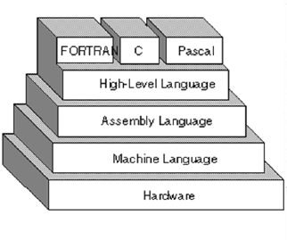

To program in assembly, you will need an assembler and an editor.

## Assemblers

An assembler takes the written assembly code and converts it into machine code. Often, it will come with a linker that links the assembled files and produces an executable from it. Windows executables have the .exe extension. Here are some of the popular assemblers:

1. **MASM** – This is the assembler this tutorial is geared towards, and you should use this while going through this tutorial. Originally by Microsoft, it's now included in the MASM32v8 package, which includes other tools as well. You can get it from <http://www.masm32.com/>
2. **TASM** – Another popular assembler. Made by Borland but is still a commercial product, so you cannot get it for free.
3. **NASM** – A free, open source assembler, which is also available for other platforms. It is available at http://sourceforge.net/projects/nasm/. Note that NASM can't assemble most MASM programs and vice versa.

## Editors

An editor is where you write your code before it is assembled. Editors are personal preferences; there are a LOT of editors around, so try them and pick the one you like.

1. Notepad – Comes with Windows; although it lacks many features, it's quick and simple to use.
2. Visual Studio – Although it's not a free editor, it has excellent syntax highlighting features to make your code much more readable.
3. Other – There are so many Windows editors around that it would be pointless to name all of them. Some of the more popular ones are:
   1. Ultraedit <http://www.ultraedit.com/>
   2. Textpad <http://www.textpad.com/>
   3. VIM <http://www.vim.org/>
   4. Emacs <http://www.gnu.org/software/emacs/emacs.html>
   5. jEdit <http://www.jedit.org/>

## Installation of MASM615

Copy the MASM615 folder provided to you in your C drive. Your assembler is now ready to be used.

You can create a separate directory where you would like your work to be saved.

## Your First Program

Now that we have our tools, let's begin programming! Open up your text editor and following the instructions below. This is the most commonly written program in the world, the "Hello World!" program.

**First Program in Assembly**

1. Look for the **make32.bat** file in the Masm615 directory. Copy it to your working directory
2. Open **Notepad** and copy paste the following code:

INCLUDE Irvine32.inc;

.data

Msg1 BYTE "Nothing is impossible, I am doing nothing.",0

.code

main PROC

mov edx,OFFSET Msg1

call WriteString

exit

main ENDP

END main

1. Save the file into your working directory by the name “**first.asm**”.
2. Open a DOS/command prompt window. Do this by selecting Run from the Start menu, and run cmd.exe. (If that doesn't work, try running command.com instead.)
3. At the command prompt, move to your working directory and type the following command:

**make32 first**

You should see the following output screen. It shows the execution of the Microsoft Assembler, the Linker, and lists all filenames in the current directory beginning with "first":

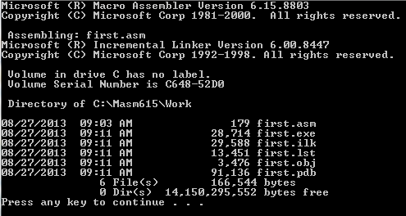

**Note**

* File Name is not case sensitive in MS-DOS.
* Novice user should feel free to ask instructor about some basic commands of MS-DOS.

The file “*first.exe*” is called the executable program. Run this program by typing ***first*** at the command prompt. You should see the following:



If you received this output, then you have installed the assembler correctly.

You can create an error by changing or deleting any word from first.asm

E.g. delete the word MOV from this file and then assemble it as above, you will get an error message.

# Tasks

**1.** Assemble & Link some sample examples.